LANDSCAPING

POLICY NUMBER: LPP10

STATUTORY BACKGROUND

This Policy is adopted under Part 2 of Schedule 2 of the Planning and Development (Local Planning Schemes) Regulations 2015 which enables the City of Kalgoorlie-Boulder to prepare local planning policies for any matter related to the planning and development of the scheme area.

PURPOSE

The purpose of this policy is to provide guidance on the minimum standards and expectations for landscaping associated with development applications.

OBJECTIVES

This Policy serves to set out design considerations that will create attractive, functional, safe, low maintenance, low water tolerant and desirable landscape outcomes that will assist to:

- Incorporate landscaping as a fundamental element of the design process to ensure integration with development in a meaningful and functional manner;
- Ensure a suitable provision of landscaping relative to development size to complement and soften the built environment, reduce the dominance of hard surfaces and articulate open space;
- Provide for shade and green relief in built up areas to minimise the effects of urban heat island;
- Minimise environmental health issues through dust suppression;
- Encourage the retention of existing native plant species to promote environmental sustainability; and
- Enable landscaping designs to be easily maintained and suitable for the environmental conditions.

DEFINITIONS

Refer to (insert clause) Terms Referred to in Scheme of the City of Kalgoorlie-Boulder Local Planning Scheme No. 2 (the Scheme). Additional terms used within this policy not defined within the Scheme are defined below.

Landscaping means the carrying out of work which improves the appearance and function of a piece of land by reshaping and preparing the grounds, planting suitable plants, mulching of garden beds, installation of adequate irrigation systems and ongoing maintenance.

Hard Landscaping means heavy landscape materials including stone, flagstone and rock, typically used in conjunction with soft landscaping to distinguish boundaries, create pedestrian avenues or in the retaining of loose ground and soil. Hard landscaping also includes decorative features but does not include standard features such as Colorbond® fencing and concrete driveways.

Soft Landscaping means vegetative materials including trees, soil, flowerbeds, vegetable gardens, grass and shrubs, used in the course of improving areas external to a building.

Landscaping Plan mean a scaled drawing of a development conceptually showing the extent, function, context and attributes of areas to be landscaped, including plant functions (screening, shade, low and ground cover) walkways, paving, planting water features, fencing and wind barriers.

Maintenance Schedule means the provision of all services required to maintain and preserve the soft and hard landscaping on the site.

RELATED LEGISLATION

This Policy is to be read in conjunction with the following document:
- State Planning Policy 7.3 - the Residential Design Codes (the R-Codes) Volume 1 and Volume 2 – Apartments.

APPLICATION OF POLICY

The local government will give due consideration to the guidelines included in this Policy, when considering landscaping plans and maintenance schedules prepared under Local Planning Scheme Number 2 (LPS2).

The provisions of this Policy apply to all development and are in addition (supplementary) to the requirements specified under the applicable volume of State Planning Policy 7.3 Residential Design Codes.

POLICY PROVISIONS

This is to be read in conjunction with LPS2 – Clause 34 Landscaping and site maintenance.

Landscaping plays an integral role in shaping the amenity of any given area, and will typically improve visual appearance, moderate temperature (reduce temperature extremes), and assist in managing stormwater runoff. Landscaping can also provide social and cultural benefits, forming a key part of the character and history of local areas, often supplementing and improving the amenity of the built environment.

The maintenance of landscape areas forming part of development must be maintained, and all applications will be required to submit a detailed landscape maintenance plan. These plans will form part of the development approval conditions.

Landscaping Guidelines
To achieve the Policy Objectives, the following guidelines should be given due consideration when developing a landscaping plan.
- General Landscaping Guidelines:
- Prioritisation of landscaping in areas visible to the streetscape;
- Landscaping of a minimum width of 1m is required along the street boundary;
- Maximise opportunities for street tree retention where possible;
- Prioritise the retention of existing trees over removal and replacement options;
- Landscaping appropriately integrated with car parking areas, where Schedule 1 of this Policy demonstrates an acceptable design solution;
- The use of both hard and soft landscaping design measures; and
- Use of plant species contained in the City provisions which reflect the climatic and soil conditions.
Objectives | Guidelines
Enhance the visual amenity of the City through landscape beautification. | - Use of art or sculptures in landscaping;  - Use plant species that use a mix of coloured flowers;  - Use local plant species set out; and  - Incorporate Perennial plant species for year-round flowering cycles.
Provide for shade and green relief in built up areas to minimise the effects of urban heat islands. | Plant mature trees with a minimum height of 1m or as defined by the R-Codes for residential proposals;  Use of plant species that provide a year-round canopy cover;  - Minimise the use of hardstand areas where possible; and  - Select plant species that are evergreen.
Ensure landscaping is safe and accessible for the public. | - Locate and design landscaping to avoid impeding traffic movement and sight lines along access ways and driveways;  - Avoid landscaping that creates hidden areas or areas of concealment;  - Maintain clear sight lines between road and building entrances;  - Use hard landscaping design measures to delineate between private landscaping and public areas; and  - Avoid using plant species that have thorns or sharp objects.
Minimise environmental health issues through dust suppression. | - Use of mulch in all landscaping beds to ensure adequate coverage;  - Use of ground-cover plant species; and  - Maintenance schedule to achieve minimum watering frequency.
Encourage the retention of existing native plant species to promote environmental sustainability. | - The siting of buildings is to consider the retention of existing native plant species and utilisation as design features;  - Show the location of existing native plant species in landscape design;  - If existing native plant species are to be removed this must be shown on the plan and justification provided as to the reason the existing trees are to be removed; and  - Nominate plant species that complement the existing native plant species that will be retained.
Enable landscape designs to be easily maintained and suitable for the environmental conditions. | - use of reticulated potable or non-potable water supply;  - Drought tolerant species integrated into landscape design;  - Use of mulch and its regular replacement and upkeep;  - Plants are regularly fertilised with appropriate nutrients for species;  - Use naturally occurring plant species to reduce pruning regimes; and  - Use of on-site water harvesting if achievable

DESIGN VARIATIONS

Variations to Scheme provisions must demonstrate how to achieve the objectives of this Policy. The guidelines pertinent to the objectives should be used as a basis to achieve the variation.

Where a site subject to a planning application contains existing native vegetation which the Council considers worthy of retention, the Council may vary other provisions of the Scheme or this Policy (where these provisions may be lawfully varied, and such a variation is considered to be acceptable) to enable the retention of the vegetation.

LANDSCAPING PLAN REQUIREMENTS

Landscaping plans prepared under LPS2 should include the following details:
- Scale, north point, site level contours, all lot boundaries and dimensions;
- Materials and finishes of all external areas, inclusive of areas for vertical landscaping, landscaped balconies, vehicle access and parking (details of lawn variety, mulch type and depth, nature of any hard surface);
- Plant schedule indicating botanical name, quantity, pot size, height and spread at maturity for proposed plants (generic legends not satisfactory);
- Location of all plants in the schedule clearly indicated on plans;
- Reticulation type and method of operation;
- Notes on any specific maintenance requirements;
- All verge areas adjoining the site including existing street trees;
- Nature of any barrier separating landscaped areas from vehicle manoeuvring areas;
- Site lighting;
- Verge treatments; and
- Maintenance including but not limited to watering frequency, feeding and fertilisation schedules and mulching.

The level of detail required for landscaping plans may be varied by the City on a case by case basis with consideration to the scope and nature of development being proposed.

An example of a landscape and maintenance plan is provided in Schedule 2 and 3 of this Policy.

SCHEDULE 1: CAR PARK LANDSCAPING

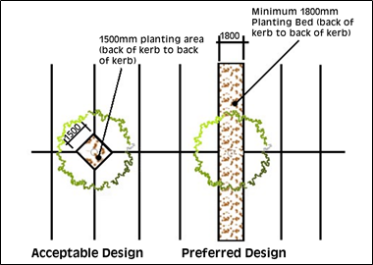

SCHEDULE 2: LANDSCAPING PLAN EXAMPLE

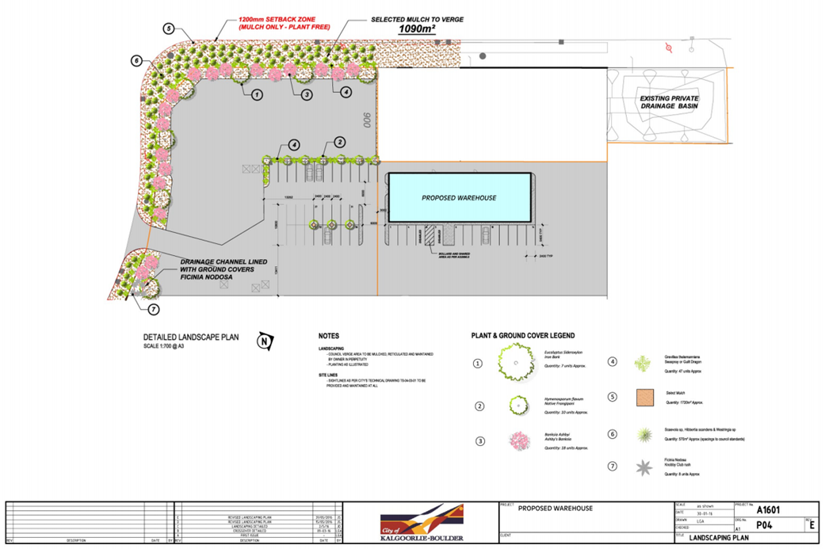

SCHEDULE 3: LANDSCAPING MAINTENANCE PLAN EXAMPLE

Initial maintenance program during establishment period:
- The gardens will be managed by a landscaped irrigation system.
- Plants will be irrigated several times a week as required during the initial establishment period depending on rainfall with a timing device.
- Under the Construction Contract, for an initial 12-month period, the appointed landscaper will visit the site at a minimum once a month and replace any plants lost, prune plants and remove weeds as required by management.
Thereafter a full-time contract will be issued to continue a maintenance program including but not limited to:
- Weed and neaten the landscape areas once every 2 months or as required by management instruction.
- Assess if there has been any plant loss every 6 months and replace accordingly or as required by management instruction.
- Mulch the landscape area every 12 months or as required by management instruction.
- Set the irrigation timer to twice a week during the hotter summer months, in accordance with the Sprinkler Roster for South Area 2 and reduce to once a week during the cooler winter months or as required by management instruction.

Date Adopted: Insert OCM details and date | Item Number: Insert OCM Item No.
Delegation: Ordinary Council Meeting | Revision Number: 1
Authority: City of Kalgoorlie-Boulder Local Planning Scheme No. 2 2021 (as amended)

